Project 2

Frederick Kelemen

2715308

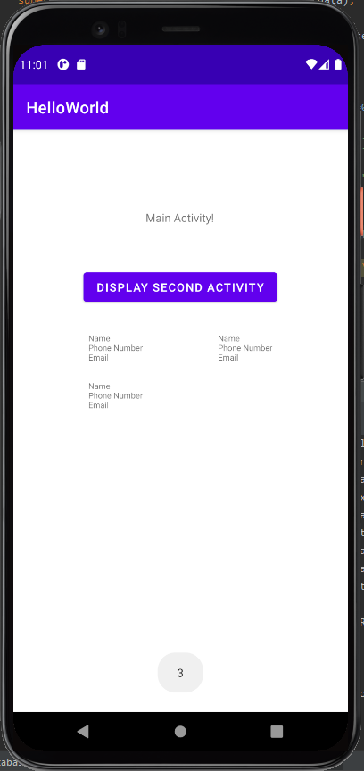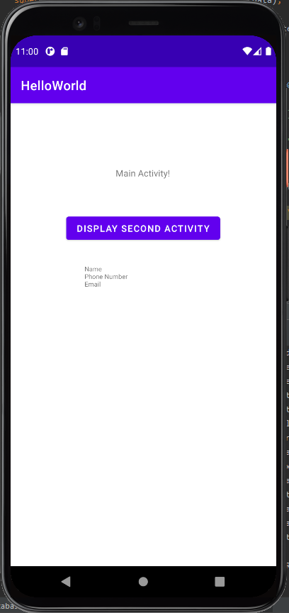My project 2 is horribly inefficient, it uses textviews to store the contacts, It does however have a pseudo-persistence, that is the data is persistent but it gets wiped in the onCreate function, the persistence is implemented through SharedPreferences. The preferences store the count, names, emails, and phone numbers. Because I used textviews the number of contacts is maxed out at 10 going above 10 causes the app to crash.